**Fluid Dispenser Bottle Construction:**

1) Gather all materials -

* Square Nalgene bottle
* Threaded 1/4" ID tubing connector
* Approx. 2" 1/4" ID 3/8" OD tubing
* Enough 1/8" ID tubing to span between bottle and pump
* Luer lock pieces for connecting 1/8" to 1/4" tubing
* 2 Pinch valves for each size of tubing
* Tubing connector piece from peristaltic pump
* Drill and 5/16" drill bit
* Parafilm lab wax
* Needle nose pliers
* Ruler

2) Fit all tubing pieces together (pinch valve for larger tubing not shown here, but shown below)

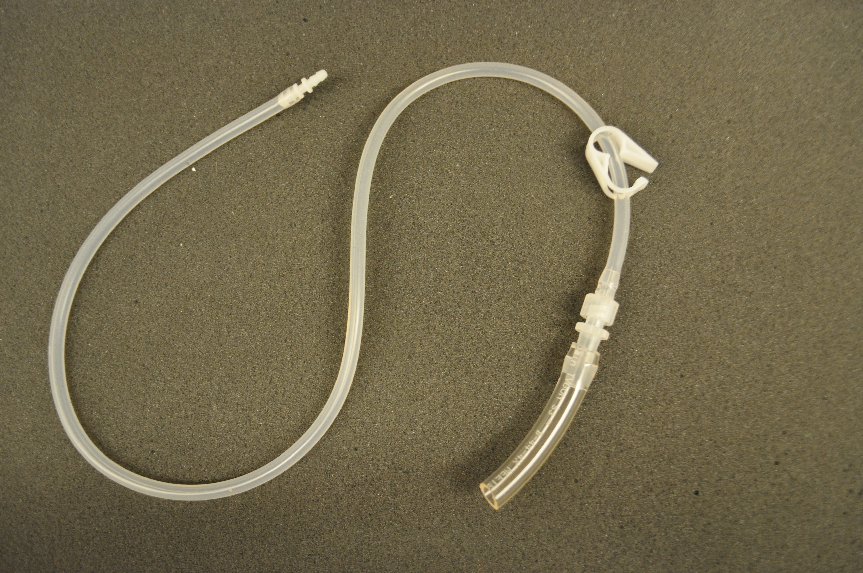

3) Mark a spot 3/8" from the bottom of the Nalgene bottle and drill a hole, clean off any plastic bits from the edges.

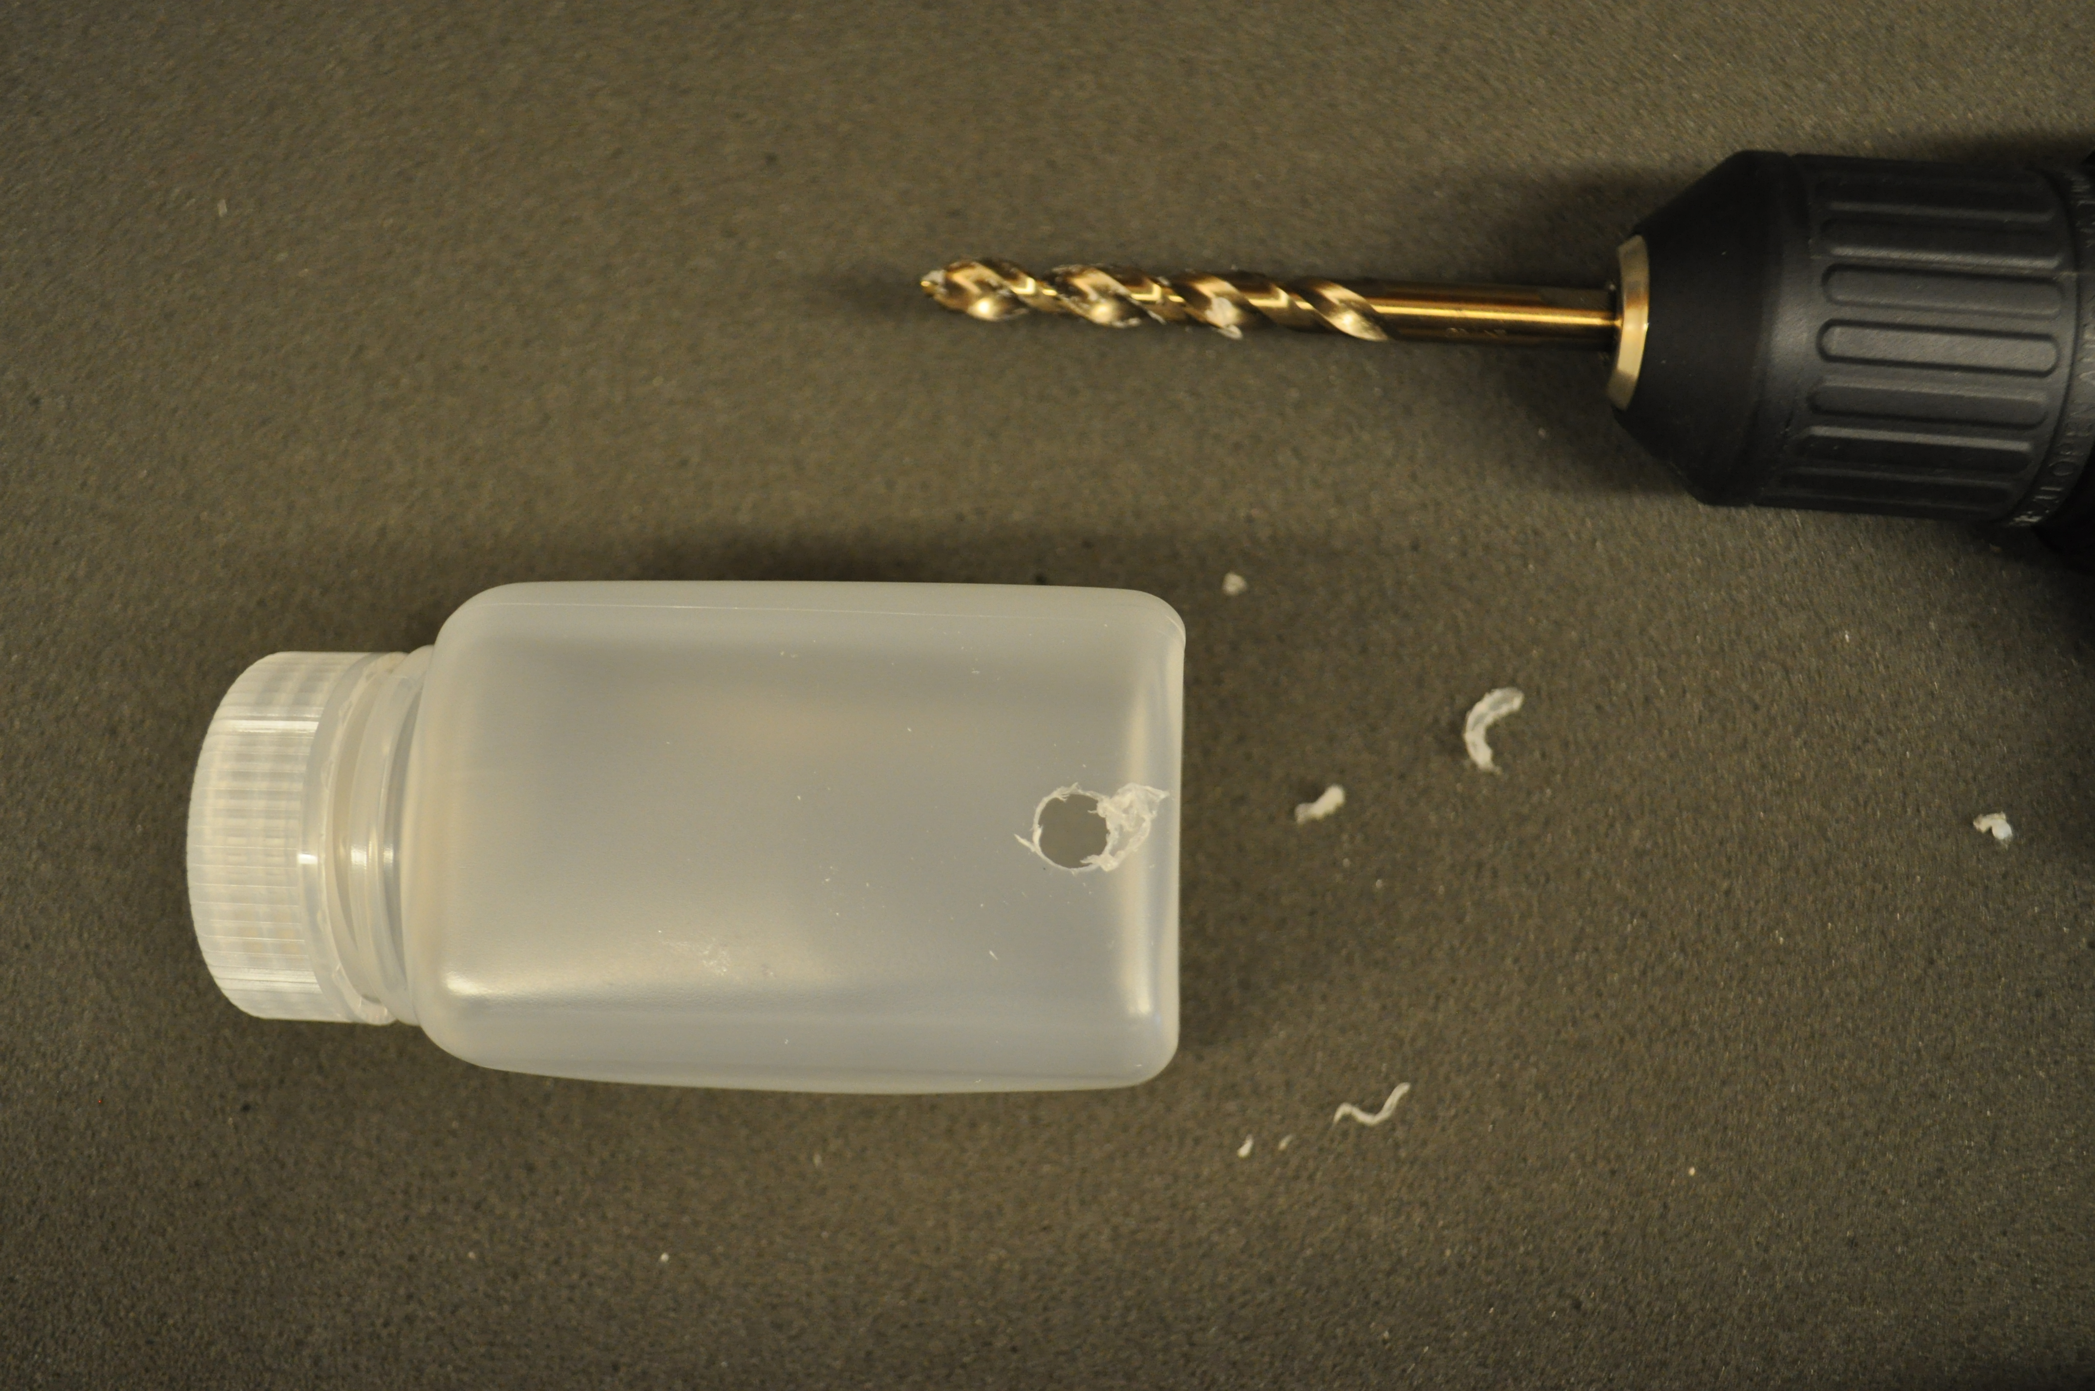

4) Wrap a small amount of parafilm around threaded tubing connector piece

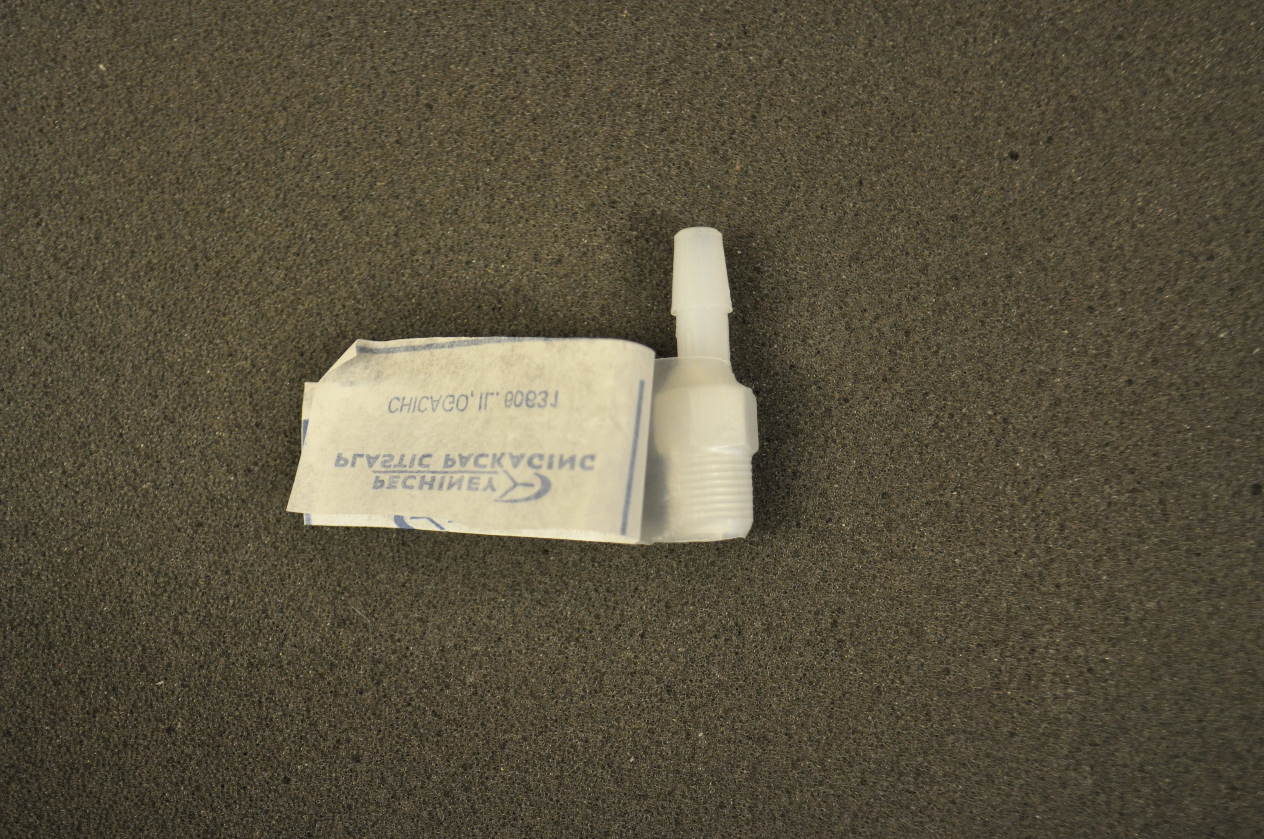

5) Force fit connector piece into drilled hole. A pair of pliers will be helpful to do so.

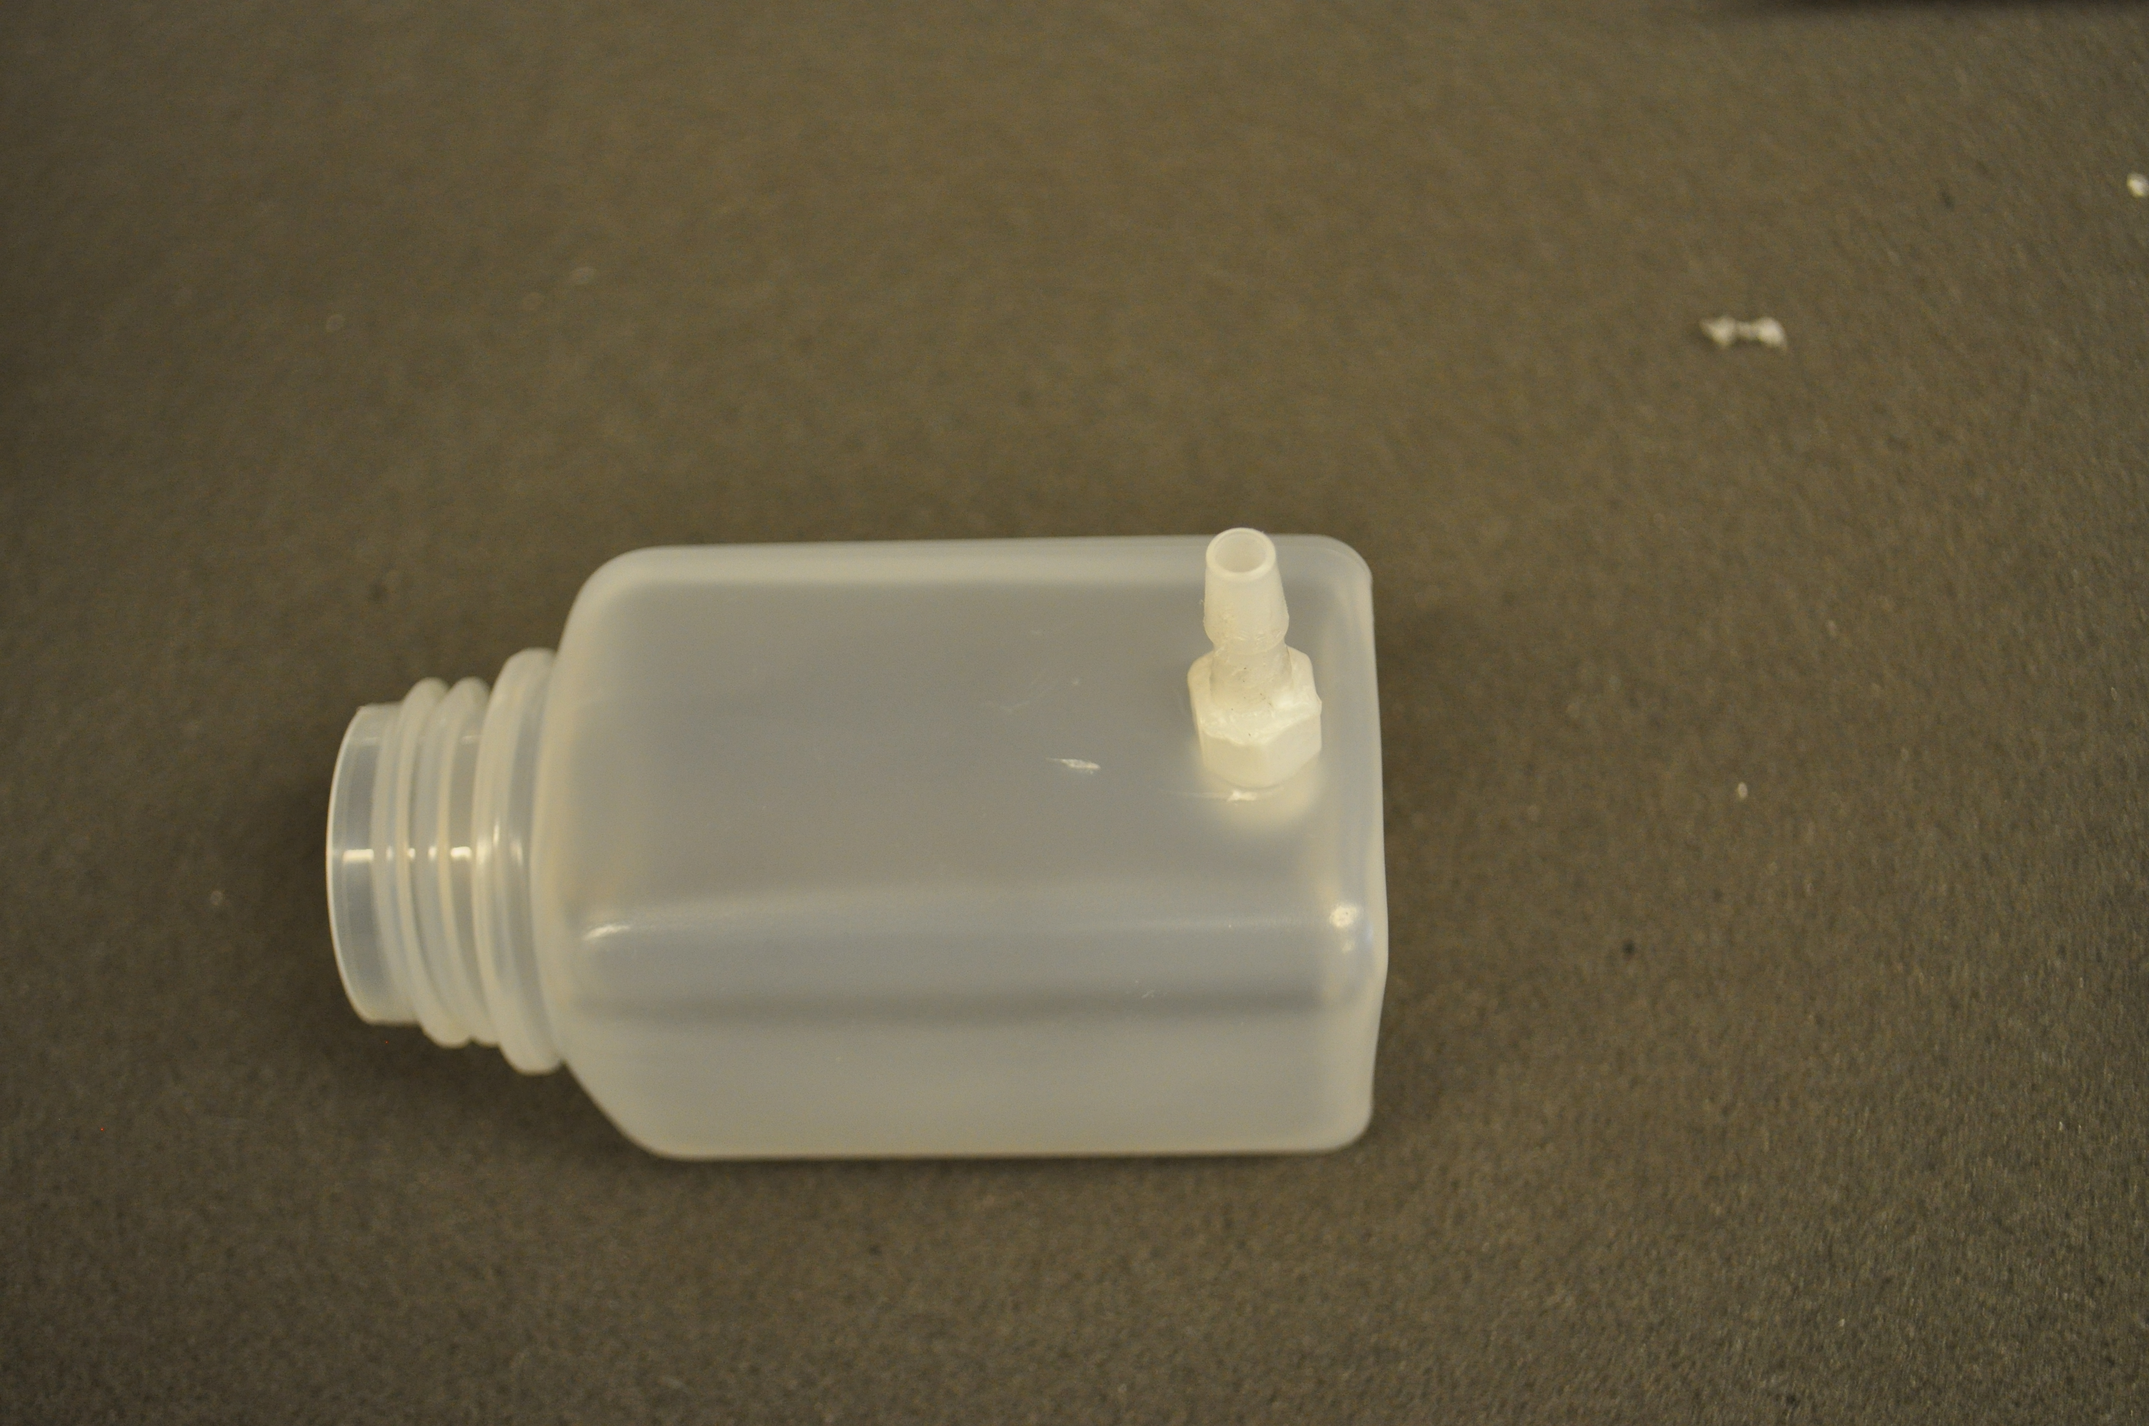

6) Slide 1/4" ID tubing (with pinch lock) all the way onto connector.

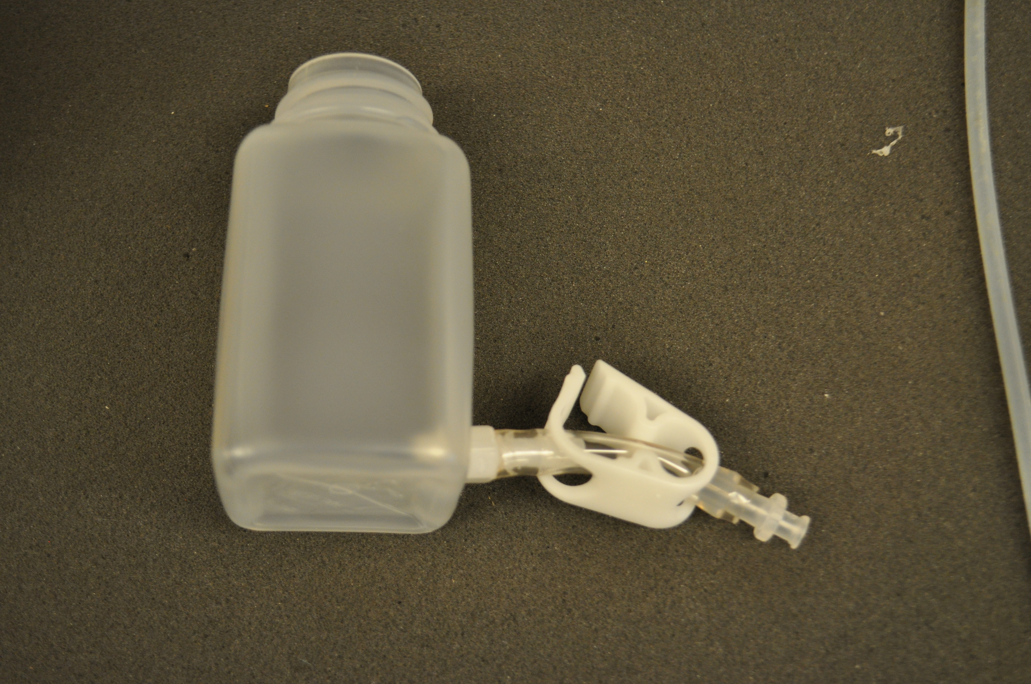

7) Check for leaks by engaging the pinch valve and filling the bottle with water, then leaving on a paper towel overnight. If there is a leak, more parafilm may be needed.